Connecting Multiple VTI LED Posters

Connecting Hardware
Below familiarize yourself with your LED Poster’s basic input and output ports.
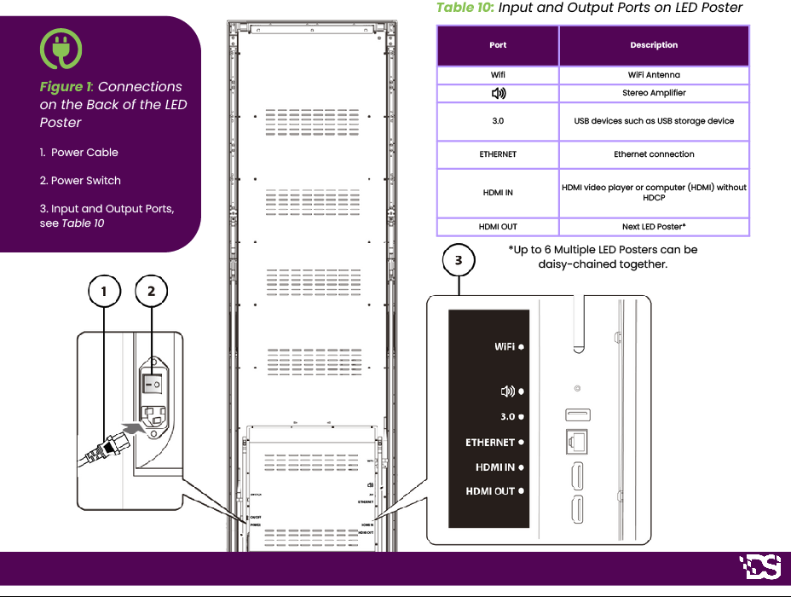
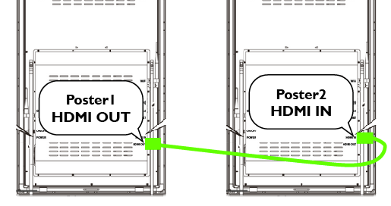

Multi-Screen Display
To connect two or more LED Posters, you simply need to connect the “HDMI OUT” of Poster1 to the “HDMI IN” of Poster2. (see right)

Poster1: HDMI OUT | Poster2: HDMI IN
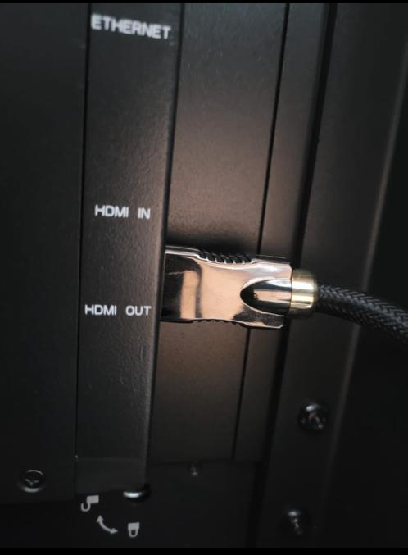 | 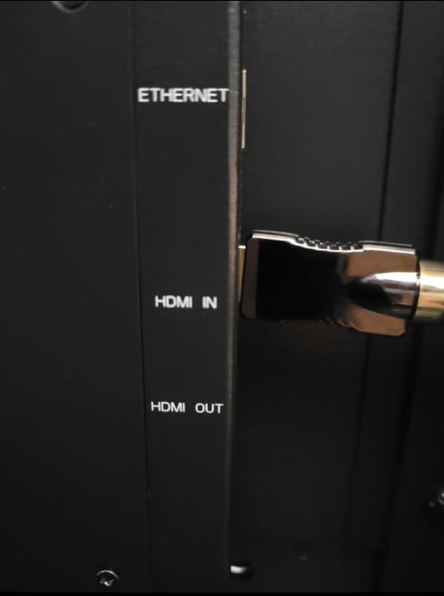
Seamless Video Wall  To fit LED Posters together for a seamless Video Wall you only need to:  - Remove the magnetic sidebars (see right) between two posters.  - Station LED Posters next to each other (see below).  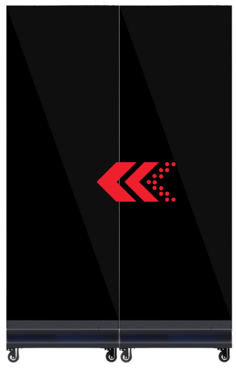 | 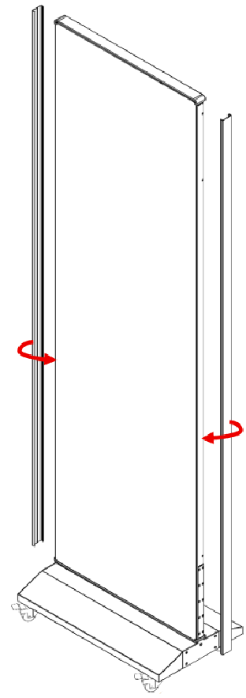
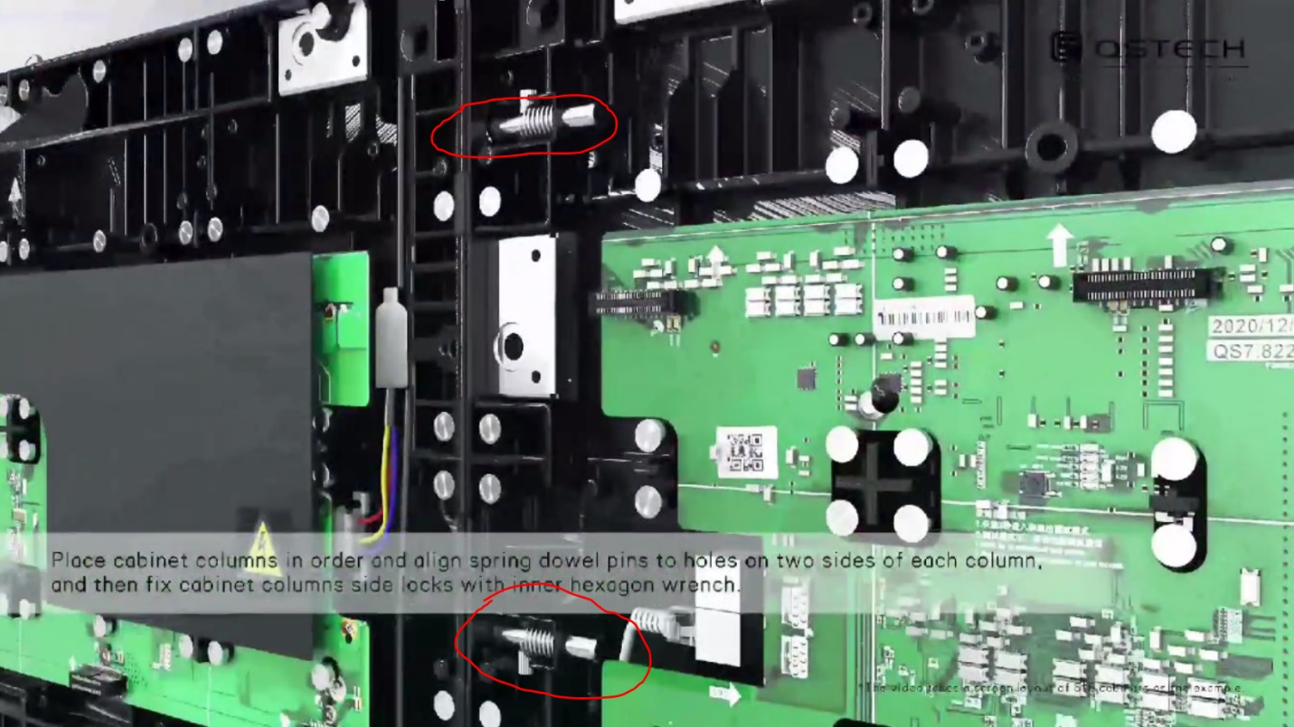
- Remove the modules between two posters, which cover the *sidelock of the Poster cabinet
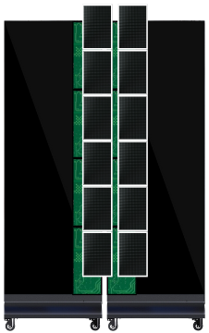 | 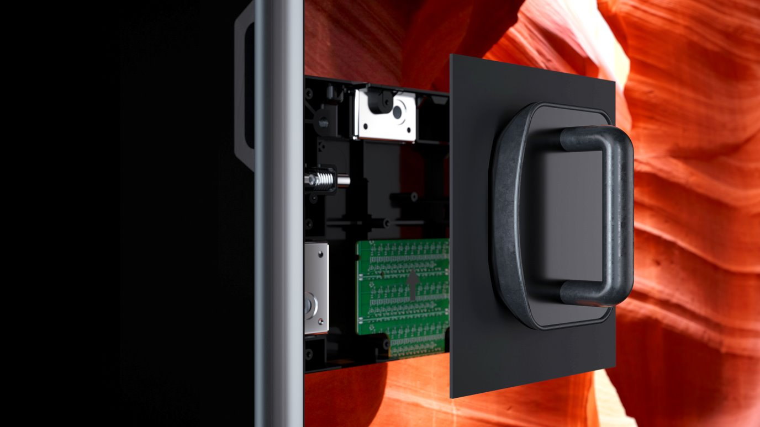Use magnet included in LED Poster kit.
*Side locks (pictured below)

- Wrench the side lock and screws as shown in the attached video.
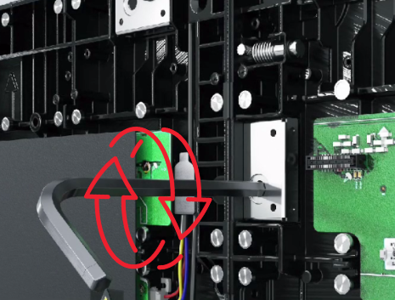

- Connect the Poster1 HDMI OUT to the Poster2 HDMI IN.

Display Content - Viplex Handy

- Connect to Screen
  - Click Set Network to access the WLAN connection page of the mobile phone.
  - Connect the WiFi AP of Taurus series products. (The default SSID is the last 8 digits of AP+SN, and the password is 12345678.)
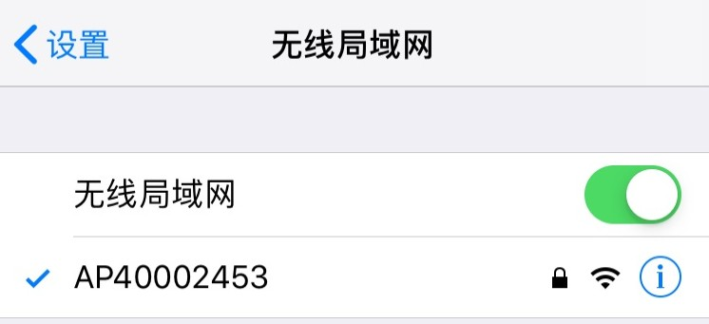

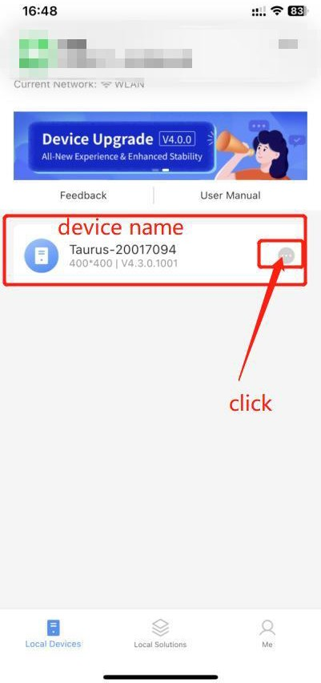
- Run ViPlex Handy Mobile App
Android | iOS
Download Link | Download Link

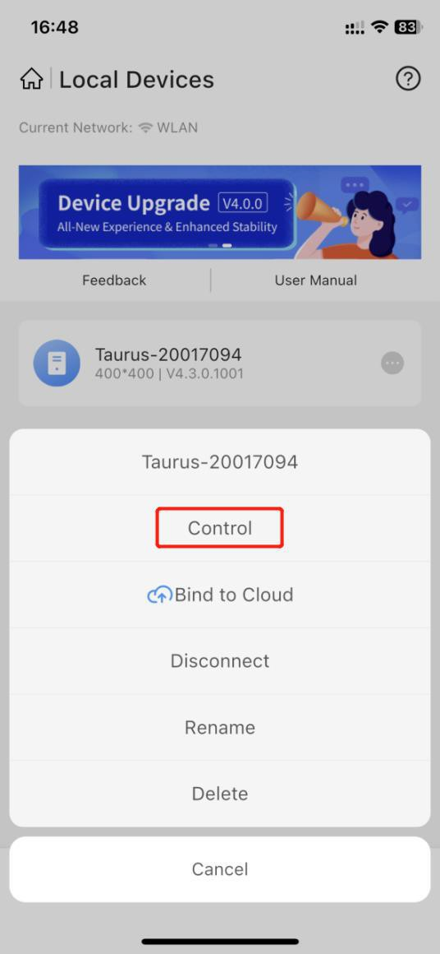
- xs

- Enter Device Management
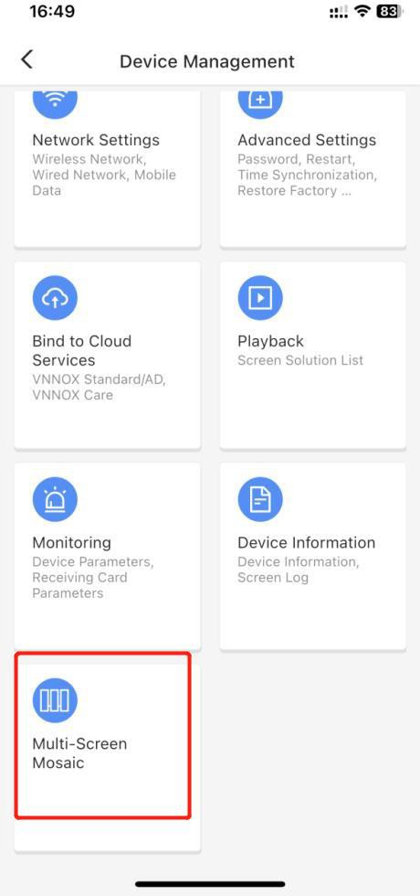

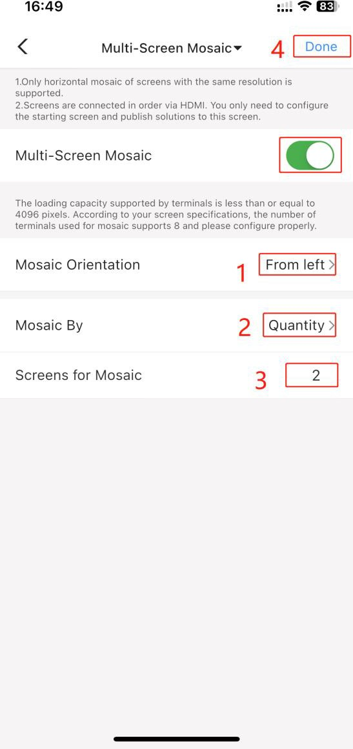
- Select the Multi-Screen Mosaic
  - Steps (shown in Red Numbering above):
    - 1) Setting of splicing direction; (If the software is connected to the leftmost poster, choose the direction from left to right (facing the screen))
    - 2) Splicing method: according to the width or according to the number, we choose "quantity"
    - 3) The number of splicing should be consistent with the number of screens.
    - 4) Press “Done”.

